25 years of #ecoflagship #EMAS – show your commitment
We want to spot your EMAS achievements and present them to the world – with #ecoflagship #EMAS, a campaign that DIHK (Association of German Chambers of Industry and Commerce) starts - in collaboration with the EMAS Advisory Board - on 28 September, the 25th anniversary of EMAS. How long has your organisation been registered with EMAS? What have you achieved for the environment and the climate during this time? How many kilowatt hours of energy have you saved, how many tonnes of CO₂ have you avoided, which resources have you used more efficiently? How many fellow campaigners have you found to support corporate environmental management?

EMAS is celebrating its 25th anniversary – celebrate with us!
Environmental statement and a website – these are the classic ways to make an organisation’s environmental and climate commitment known to the public. Would you like to explore new avenues and show a wider public what you do to make your organisation more resource-efficient and climate-friendly? If that is the case, get involved in #ecoflagship #EMAS, a campaign run by the Association of German Chambers of Industry and Commerce and the office of the EMAS Advisory Board. Give a signal on your premises and be active across the digital channels.

How it works
- Show your green commitment and raise the EMAS flag on your premises. You can order EMAS flags at a low price from DIHK (see below). Or else you can of course participate in the campaign without a flag.
- Take a beautiful picture of the flag flying in front of your office - or of something else that demonstrates your EMAS commitment. Maybe with your colleagues. We have compiled a couple of tips for you below.
- Formulate a short message for your social media channels (e.g. Facebook, Twitter, Instagram) to describe your commitment. The description should be short and sweet. Please note: the limit of Twitter posts is 280 characters.
- Complete your short message with the hashtag #ecoflagship #EMAS. You can also add other suitable hashtags, e.g. #sustainable, #eco-friendly etc.
- Invite other people and institutions to share the message: send the post to others, e.g. by posting in a group or by adding @(name of person or institution) to the message.
- You can also create a link to your website and/or to your latest environmental statement.
- Post your photo and your message on 28-29 September 2020. The campaign will take place on these two days.

At the same time, a conference of the Federal Environment Ministry will be held in Berlin to celebrate the 25th anniversary of EMAS, along with workshops of the EMAS Advisory Board, in collaboration with the Association of German Chambers of Industry and Commerce (more detailed information about the events will be available very soon at www.emas.de).
We will be delighted to receive your posts on Twitter or Facebook. We will ‘like’ your posts and forward them: Facebook: @EMAS @DIHKBerlin, twitter: @DIHK_News

Where can I get an EMAS flag?
The Association of German Chambers of Industry and Commerce now gives you the opportunity to buy one or more EMAS flags with a German or English logo at a very reasonable price in a collective purchase order. Delivery (with invoice) will be made to you directly by the printing company. You can request an order form by sending a short email to emas@dihk.de.

If you have any further questions about the campaign, please contact us:
DIHK (Association of German Chambers of Industry and Commerce e. V.): Martina Stirnberg, emas@dihk.de, Tel. +49 30 20308 2205
UGA Office (German EMAS Advisory Board): Frank Kermann, info@uga.de, Tel. +49 30 297732-34

Expanding your reach - internally and externally: tips for a successful social media campaign
What can you do to launch a creative and effective advertising campaign? Here are some ideas to inspire you:
Bring your employees on board
- Show the campaign to your communication and marketing team and get them involved. A professional photo or video makes advertising more effective. In the best case, it can lead to a new advertising campaign that brings more authenticity to your business.
- Initiate an internal photo competition for all employees who are involved in environmental management.

Get more out of your photo
Display your data, e.g. CO₂ emission reductions as shown in your environmental statement, in an unconventional, original manner, e.g. by creating funny graphics or illustrations: joy jump images, apple slices, pie charts, hugs, cent pieces, Lego bricks and pieces, pebbles, sit-ups, rope skipping images, cubic metre of air, distances between two objects, …
EMAS as solid proof of credible environmental and climate commitment
Show what you and your employees have achieved with your own hands within your organisation in the field of environmental protection and climate action. Initiate an internal photo competition - criteria for entries could be: show at least one hand, one EMAS environmental performance indicator, and the EMAS logo.
Moving pictures for greater impact
It is also possible to publish a short video - to film scenes (25 seconds max.) with a mobile phone or a camera. The content could be:
- Capture words or statements from your colleagues about your organisation’s green commitment
- Which showpiece projects have you been able to implement within the framework of EMAS, and what CO₂ emission reductions have been achieved?
- Original everyday scenes from your work in environmental management
- Creative designs to visualise data from your environmental statement (e.g. baking a real pie-chart, fruit salad, Origami folding paper, …)

Posting example
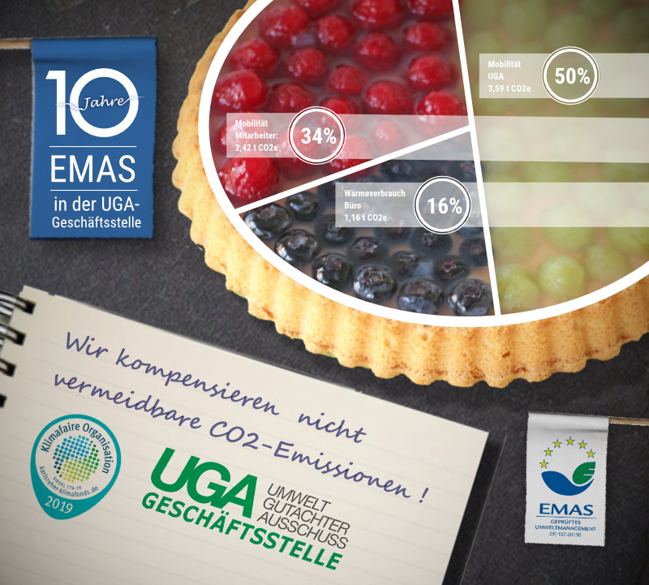 | We are fair on the climate: www.emas.de/uga-geschaeftsstelle #ecoflagship #EMAS for #climate action and #sustainability @EMAS @DIHKBerlin

More inspiration for your campaign
What have others done on social media that could inspire you? Here are a few links to give you some ideas:
https://swat.io/de/strategie/15-kreative-social-media-kampagnen/
Tools for your smartphone
Nowadays you don’t have to be a commercial artist to create beautiful collages from photos and enhance them with text and graphics. On a smartphone, it is also possible to cut video and image sequences and put them together into a little film. A variety of apps can turn the snapshots on your mobile phone into interesting collages or even works of art:
- apps für photo collages: https://www.pixolum.com/blog/fotografie/foto-collage-apps
- bizarre photo apps: https://futurezone.at/apps/die-lustigsten-und-skurrilsten-foto-apps-fuer-ios-und-android/400504378
- apps for video editing: https://www.basicthinking.de/blog/2019/04/03/videobearbeitung-am-smartphone/

